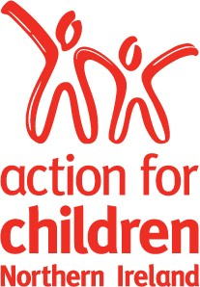

Candidate Brief
Brief for the position of Committee Member
Action for Children, Scotland

January 2015

Introduction from the Chair

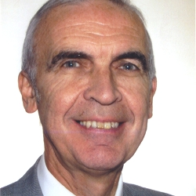
Dear prospective candidate,
Recruitment of Scotland Committee Members
Action for Children works with the most vulnerable and neglected children and young people across the UK and has done so for over 140 years. At Action for Children, we have a vision of a world where all children and young people have a sense of belonging, and are loved and valued – a world where they can fulfil their potential, shape their destiny and experience the joy of life. Through our policy and campaigning work, we encourage governments to spend more - and more wisely - on public services that focus on early intervention, and raising desperately needed money to develop targeted, proven, effective initiatives that tackle the key causes of child neglect.
We work directly with more than 250,000 children, young people, parents and carers each year, through our 650 services across the UK. Our annual income and expenditure is around £180m and voluntary donated income is £15m.
In Scotland we have 82 services working with around 4000 children young people and families. One of our trustees, Kate Guthrie, is the Chair of the Scotland Committee
It is an exciting and challenging time for us and we are looking for a number of exceptional individuals to join us on this journey, at national committee level, as members of our Scotland Committee.
.We will particularly welcome individuals with skills or backgrounds in health and/or social care policy development and/or delivery; local authority commissioning; business/financial expertise; policy work, particularly with a Scottish government or lobbying focus.
If you are interested in the above role, we would be delighted to hear from you.
Yours sincerely,
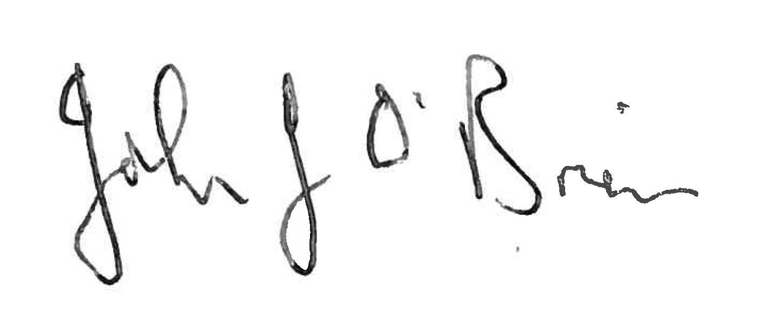
John O’Brien
More information is available at www.actionforchildren.org.uk

Context
Action for Children, in common with many in the voluntary sector, faces turbulent and challenging times as a combination of the economic crisis, government policies and deep cuts in public spending place pressure on the provision of services for children and young people. Action for Children’s emphasis on working with the most vulnerable and disadvantaged children and their families – those most open to poverty and neglect – means that it faces significant demands to deliver continuity in the quality and scope of our services.
Nearly 90% of its income comes from local authorities and Health and Social Care Trusts who commission services. Because of its determination to be there for the most vulnerable children, it is important that the charity delivers consistent quality at lower cost whilst maintaining its campaigning stance with governments and other stakeholders. With local authority commissioners’ looking for greater value for money, this context provides opportunities to provide new solutions including the clustering of services and the development of innovative partnerships.
These initiatives are being actively pursued whilst Action for Children looks for ways to deliver its existing services through internal efficiency and overhead reduction. Within Action for Children itself, there are a number of organisational change initiatives underway or planned, including a major reconfiguration of its service delivery organisation and a review of reward and pay structures.
This context provides the backdrop for the recruitment of a number of co-opted committee members to help lead the charity through this exciting and challenging time in our development.
Action for Children has three national committees, supporting its activities in Northern Ireland, Wales and Scotland. Action for Children is seeking to recruit three individuals to sit as co-opted members (not trustees) on its Scotland committee. In particular, individuals with the following skills / background would be particular interest:
- Health and/or social care policy development and/or delivery
- local authority commissioning
- business/financial expertise
- policy work, particularly with a Scottish government or lobbying focus
- Role Description

Committee Member, Scotland
To participate fully as a co-opted member of the Scotland Committee and to bring their personal skills and experience to the role by ensuring that the Committee plays an active role in overseeing the delivery of high quality services to children and young people and their families in Scotland.

Key responsibilities
- To monitor the performance of Action for Children through oversight of the business plan for Scotland
- To monitor and review implementation plans for any UK-wide strategies which have been approved by Council.
- To contribute fully to discussions as a co-opted member of the Scotland Committee
- To become familiar with the work of Action for Children
- To safeguard the good name and values of Action for Children
- To develop links with projects in their locality in order to develop an understanding of Action for Children’s work.
- To undertake any induction, development or other training which may be required
- To have regard to any areas where there may be potential for conflict with any aspect of Action for Children’s strategy and ensure that these issues are raised with the Committee Chair, where necessary.

Person Specification

Essential qualities
We are looking for candidates who can demonstrate:
- An understanding of, and commitment to, the values of Action for Children
- A record of proven and significant achievement in their own field
- A proven track record of strategic leadership and harnessing a range of motivational skills.
- Demonstrable experience of building and sustaining relationships with colleagues and stakeholders to achieve organisational objectives

Knowledge/experience
- An understanding of, and commitment to, the values of accountability, probity and openness.
- Sound, objective judgement and decision making.
- Confident and effective communication skills with a range of audiences.
- A track record of commitment to promoting equality and diversity.

Terms of appointment

Remuneration:
Committee Members are unremunerated but reasonable expenses are reimbursed

Meetings:
Meetings will be held in Scotland although some training may take place in London.

Time Commitment:
It is anticipated that this role may require up to 1 day per month.

Application Process

Timetable
Closing date for applications: 10 February2015
There will be 2 interviews, including a Young People Panel on:
21 February 2015
The second interview to be arranged.

How to Apply
Application is by submission of CV and a cover letter, outlining why you believe yourself to be suitable for the role, to be no longer than 2 A4 pages. Please provide evidence of your achievements against the bullet points of the person specification above and be sure to include your full contact details including daytime and evening telephone numbers.
To apply please email your application to Rebecca Hawkins at Rebecca.Hawkins@actionforchildren.org.uk or post to: 10 Great Queen Street, London, WC2B 5DG
Late applications will not be considered.

